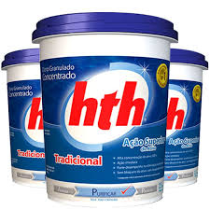

***DE: 209,80***

***POR: 195,00*** **à vista. (dinheiro )**